**UNIT - 4**

**PROJECT MANAGEMENT**

**NETWORK ANALYSIS**

Network is a graphical presentation of all the project activities showing their inter relationship. It is a logical diagram after incorporating events and activities.

**RULES FOR NETWORK CONSTRUCTION**

1. Each activity is represented by only one arrow in the network.
2. Network should be developed on the basis of logical or technical dependencies between various activities of the project.
3. The arrow representing activities are indicative of the logical precedence only.
4. The arrow direction indicates the general progression in time.
5. No event can be reached in a project before the activity which immediately proceeds is completed. Similarly, no activity can be started until the event which immediately precedes it has been reached.
6. Events or nodes are identified by the numbers.
7. The activities are identified by the numbers of their starting and ending events.
8. A network should have only one initial and one terminal node.
9. Events may be a merge, burst or merge and burst events.
10. Dummy activities have to be used if there are parallel activities between two-events, without any intervening events.
11. When two or more activities and their immediate predecessors have some common activities, dummy activities have to be used.
12. Looping is not permitted in a network.
13. Errors like dangling and redundancy are to be avoided.

---------------------------------------------------------------------------------------------------------------------

**STEPS TO DEVELOP A NETWORK AND ITS COMPONENTS**

In project scheduling the first step is to sketch an arrow diagram called network diagram which shows inter-dependencies and the precedence relationship among activities of the project.

To develop a network, the following steps are followed:

1. Break down the project into smaller activities.
2. Define the activities of the project.
3. Estimate the duration of each activity.
4. Identify the precedence relationship among various activities.
5. Draw the network using the above information in the form of circles connected by arrows.
6. Note that events are represented by circles and activities are represented by arrows.

------------------------------------------------------------------------------------------------------------

**FULKERSON’S RULE**

Fulkerson’s rule is used to assign the numbers to the events. In a network diagram to give numbers to events or node points is called ‘Fulkerson Method’. The activities joining the nods can be better identified on the network by the event numbers or node numbers at the start or end point of an activity. In a network diagram activities consumer some resources like time, money etc., which are represented like a, b, c, etc.

**Fulkerson’s Rule:**

1. There is a single initial event in the network diagram. Number this initial event as ‘A’.
2. An initial event is one, which has arrows coming out of and entering it.
3. Delete all arrows emerging from event 1.
4. Number these new initial events as ‘’2, 3, 4,- - - - ‘’.
5. Delete all emerging arrows from these numbered events which will create new initial events.
6. Follow set ‘’4’’.
7. Continue until the last event which has no arrows emerging, from it is obtained.

----------------------------------------------------------------------------------------------------------------

**CRITICAL PATH METHOD (C.P.M.)**

The critical path analysis is an important tool in production planning and scheduling. This was developed in 1957 and is suitable for the construction of civil and mechanical projects and for scheduling plant maintenance computer systems etc. C.P.M. technique is useful to determine how best to reduce the time required to perform routine production, maintenance and construction and minimize the direct and indirect expenses. C.P.M. was first used by the research team lead by Morgan R.Walker to determine how best to reduce the time required to perform routine plant overhauling, maintenance and construction work.

CPM is used for scheduling special projects where the relationship between the different parts of projects is more completed than that of simple chain of task to be completed one after the other. This method can be used for both very simple and the most complicated tasks. With the help of C.P.M., manager can know that which operation should be started after completing particular co-operation and what is the progress of the work as related to the scheduled timings? It also tells that at what moment and in what operations time schedules are adhered to strictly so that future program me is not affected and where it may be delayed and up to what extent without affecting the last date of completion of the project.

The network is prepared in the following phases:

* + - 1. Preparation of the Network
      2. Estimation of expected time to perform each activity
      3. To compute the critical path schedule and
      4. Interpretation of results

C.P.M. is based on the assumption that the expected time is actually the time taken to complete the object.

**MAIN OBJECTIVES OF CPM**

The main objects of CPM are:

1. To find the difficulties and obstacles in the course of production process

2. To assign time for each operation

3. To ascertain the starting and finishing times of the work

4. To find the critical path and the minimum duration time for the project as a whole

**SITUATIONS WHERE CPM CAN BE EFFECTIVELY USED**

CPM techniques can be used effectively in the following situations:

1. In production planning

2. Location of and deliveries from a warehouse

3. Road systems and traffic schedules

4. Communication network

**ADVANTAGES OF CPM**

The application of CPM leads to the following advantages:

1. It provides an analytical approach to the achievement of project objectives, which are defined clearly

2. It identifies most critical elements and pays more attention to these activities

3. It assists avoiding waste of time, energy and money on unimportant activities

4. It provides a standard method for communicating project plans, schedules and cost

Thus CPM technique is a very useful analysis in production planning of a very large project.

**STEPS IN CPM**

Steps to be followed for accomplishing a project planning in CPM

1. Dividing systematically the project into various activities

2. Naming the activities

3. Arranging all the activities in logical sequence

4. Construction of arrow diagram

5. The nodes (events) and activities to be numbered

6. Finding time for each activity

7. Marking activity time on the arrow diagram

8. Early and late, start and finish times to be calculated

9. Tabulating various times and mark EST and LFT on the arrow diagram

10. Calculation of total float for each activity

11. Critical activities are to be identified and critical path marked on arrow diagram

12. Total project time to be calculated

13. Crashing critical activities of the network, in case the project duration is to be reduced

14. Optimizing the cost

15. Updating network

16. Smoothing network resources

----------------------------------------------------------------------------------------------------------------

**PROGRAMME EVALUATION AND REVIEW TECHNIQUE (P.E.R.T.)**

Programme Evaluation and Review Technique (P.E.R.T.) is a technique used for scheduling and controlling the projects. PERT is a time-event network analysis technique designed to watch how the parts of a programme fit together during the passage of time and events. The special office of the U.S.Navy developed this technique in 1957. It involves the application of network theory to scheduling problems. In PERT we assume that the expected time of any operation can never be determined exactly.

**FEATURES OF PERT**

The following are the main features of PERT:

1. All individual tasks should be shown in a network. Events are shown by circles. Each circle represents an event – a subsidiary plan whose completion can be measured at a given time

2. Each arrow represents an activity – the time consuming element of a programme, the effort that must be made between events.

3. Activity time is the elapsed time required to accomplish an event. In the original PERT, three time values are used as follows:

(i)Optimistic Time (t0): It is the best estimation of time if everything goes exceptionally well.

(ii)Most Likely Time (tm): It Is an estimated time what the project engineer believes necessary to do the job or it is the time which most often is required if the activity is repeated a number of times.

(iii)Pessimistic Time (tp) : it is an activity time under adverse conditions. It is the longest time and rather is more difficult to ascertain.

(iv)Expected Time (te) : the experiences have shown that the best estimator of time out of several estimates made by the project engineer is:

Expected time (te) = t0+4tm+tp

----------------

6

And the variance of te is given by: **

**ADVANTAGES OF PERT**

PERT is a very important of managerial planning and control at the top level concerned with the overall responsibility of the project. PERT has the following merits:

PERT farces managers and subordinate managers to make a plan for production because time event analysis is quite impossible without planning and seeing how the pieces fit together

PERT encourages management control by exception. It concentrates attention on critical elements that may need correction.

It enables forward working control as a delay will affect the succeeding events and possibly the whole project. The production manager can somehow make up the time by shortening that of some other event.

The network system with its sub-systems creates a pressure for action at the right spot and level and at the right time.

PERT can be effectively used for rescheduling the activities.

**LIMITATIONS OF PERT**

The uses of PERT technique are subject to the following limitations:

1. It is a time-consuming and expensive technique.

2. It is based on Beta Distribution and the assumption of Beta Distribution may not always be true.

3. PERT is not suitable when programme is nebulous and a reasonable estimate of time schedule is not possible.

4. It is not useful for routine planning of recurring events such as mass production because once a repetitive sequence is clearly worked out, elaborate and continuing control is not required.

5. The expected time and the corresponding variance are only estimated values.

STEPS IN PERT

Steps to be followed for accomplishing a project planning in PERT.

1. Dividing systematically the project into various activities.

2. Arranging activities in logical sequence.

3. Drawing network diagram and numbering events and activities.

4. Using three times estimate, the expected time for each activity is calculated.

5. Computing standard deviation and variance for each activity.

6. Calculating earliest starting times and latest finishing times.

7. Marking expected time, earliest starting times and latest finishing times on network diagram.

8. Calculating slack.

9. Identify and marking critical paths on network diagram.

10. Length of critical path or total project duration is found out.

11. Calculating the probability that the project will finish at due date, at last.

-------------------------------------------------------------------------------------------------------------------------------

**PROJECT CRASHING**

In CPM, time is related to cost and the object is to develop is to develop an optimum time-cost relationship. Many times it becomes necessary to complete the project earlier than the normal time.

Usually the cost of the project goes up if the project time is reduced. Likewise, if the duration is made higher, the cost will be reduced.

Project crashing is a methodology adopted to reduce the project completion time by spending extra resources. There exists a direct relationship between the extra cost and the project completion time. i.e., the project completion time can be reduced by reducing normal completion time of critical activities. So the reduction in normal time of completion is associated with a substantial increase in the total budget of the project.

PROJECT COSTS

The total project cost consists of direct and indirect costs.

Direct costs: - The costs of manpower, materials, overheads etc., that can be directly related with the project is known as direct cost. These costs shown in this figure

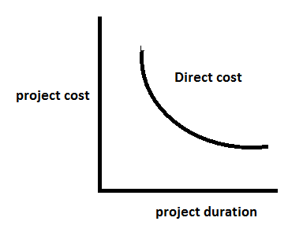

Indirect costs: - Costs like overheads, supervisor’s salaries, rent, depreciation and establishment charges etc. These costs are directly proportionate to the duration of the project. These costs shown in this figure

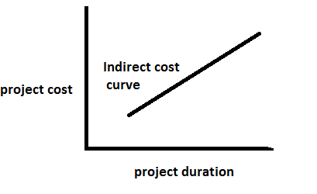

The total cost of a project is the sum of direct and indirect costs and is shown in this figure

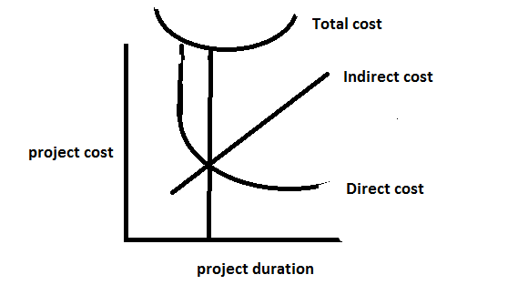

With the help of these / above curves, we determine optimum duration, which is also referred as target duration; there is no need to reduce the network i.e., crashing the duration of any activity. If however, the critical path is longer than the projects optimum duration and then there is need to reduce the duration of some activities, so that the critical path is equal to the optimum duration.

TERMINOLOGY IN PROJECT CRASHING THE NETWORK

NORMAL COST (NC):- It is the lowest cost of completing an activity in the minimum time, employing normal means not using over time or other additional resources.

NORMAL TIME (NT):- It is the minimum time required to achieve the project with normal cost.

CRASH COST(CC):- It is the least cost of completing an activity using all possible means like over time, additional machinery, proper materials etc.,

CRASH TIME (CT):- It is absolute minimum time associated with crash cost. Crash time is that time, beyond which the activity of the project. These include layout cost, material cost, land, building, draft man charges, engineering charges etc.

COST SLOPE:- The term cost slope is defined as the ‘’increase in the cost of the activity per unit decrease in the time’’ . Mathematically it can be said as



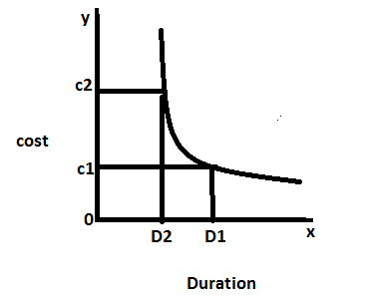

This figure shows variation in the cost of an activity with time. This figure also indicates that there is critical point in time beyond which it will become probably expensive to try to shorten the time schedule of an activity. It also indicates that lengthening of an activity more than a certain time duration results in negligible cost saving. First such point is crash point while second such point is known as normal point.

CRASHING PROCEDURE

The cost slope concept helps in finding lowest cost solution by sequential compressing the activities having lowest cost slope i.e., having lowest incremental cost on critical path. Sometimes by crashing one activity, critical path is shifted, therefore, at each shift of the critical path , it will be necessary to calculate the cost slopes of the activities on new critical path. Then the activity having the lowest cost slope needs to be compressed on this new critical path. This process is repeated until the project crash point is reached.

Procedure for crashing a project:-

The following steps are involved in project crashing to establish a time –cost trade-off for completing a project.

STEP-1 Determine the normal time, critical path and total cost associated with the path before starting crashing.

STEP-2 Calculate the cost slope



STEP-3 Select an activity for crashing which has the lowest cost slope value and reduce that activity to its lowest possible time and calculate the total cost (i.e., direct cost + indirect cost).

STEP-4 Find the new critical activity and critical path of the network resulting from crashing an activity in step-3 and calculate the new duration of a project and total cost.

STEP-5 Repeat step 1, 2, 3 and 4 till all the activities in the network are crashed to their lowest time and finally calculate the projects duration and total cost.

---------------------------------------------------------------------------------------------------------------------

**STRATEGIC MANAGEMENT**

**Corporate Planning**

Corporate planning is a planning for overall organization. The word ‘Corporate’ is used to indicate that the planning is for the company as a whole. The word corporate is also indicates that the planning task is performed at the corporate level through participation by middle management and lower management. Corporate planning consists of strategic planning, programme planning and operational planning.

**Definition**

According to Chartered Institute of Management Account (CIMA) “Corporate Planning is the process of formulation objectives as well as developing and evaluating alternative courses of action to reach these objectives based on identical external opportunities and threats and internal corporate strength and weakness”.

**Nature or Features of Corporate Planning**

The following are the features of corporate planning:

1. It is concerned with the company as a whole.

2. It determines long-term objectives of the company

3. It determines the plans of action to achieve them

4. It is the important tool of modern management

5. It is a formal and systematic approach to planning. It is a organized and structured process

6. It is continuous or on-going process

7. It is mainly the responsibility of top management

8. It is the way of taking corporate decisions systematically.

**Characteristics of a good plan:-**

Planning is a part of life for everybody. Lyndall Urwick has stated the characteristics of a good plan.

**1. It should define objectives:**

Objectives are the ultimate goals towards which all activities are directed. A statement which lays down objectives should be clear and definite and everyone in the organization should understand it in the same sense.

#### 2. It should be simple:

If a plan is expressed in a language which is not understandable by the personnel of the concern or it is complicated, it may create problems for those who are to actually put it into action.

#### 3. It should be clear:

A good plan must not contain anything that is ambiguous or indefinite.

#### 4. It should be comprehensive:

A good plan should contain all that is necessary for the attainment of the objectives of the enterprise. If a master plan is prepared for the whole organisation it will be more useful as it can be seen that nothing is left from it.

#### 5. It should be flexible:

A flexible plan adjusts the changes in the plans without any delay. Hence a plan must not be rigid. A plan should be broad enough to meet the future challenges and uncertainties.

#### 6. It should be economical:

A plan should be made keeping in mind the  
resources available with the concern and making optimum utilisation of the available resources. In other words, a plan must recover its cost and should result in the least operating cost.

#### 7. It should establish standards:

A plan must lay down the standards to be achieved. The actual performance is compared with these standards and deviations if any are noted.

#### 8. It should be balanced:

It is necessary ensure that there is a proper co­ordination between different types of plans such as short-term and long term plans, “plans of different departments etc. A business enterprise usually has a number of department’s viz., production, marketing, finance etc. Each department frames its own plans. It is for the management to see that all these plans are well balanced.

#### 9. It should be practicable:

A plan is worth only if it is practically workable and realistic. It should be formulated keeping in view the limitations of planning. If a plan is good in theory but bad in practice, it is of no use. Similarly, if the desired results are not achieved by a plan, it leads to frustration at all levels in the organisation.

**Advantages of planning**

The following are the advantages of planning

1. It provides image of the firm to be achieved over a definite period of time

2. To improve the ability of the firm to cope with change and uncertainty

3. It encourage innovative thought and creativity

4. It improve the quality of the managerial decisions

5. It is particularly useful in strategic decision-making

6. It gives away to take corporate decisions systematically.

**Limitations of planning**

The following are the limitations of planning

1. It is time consuming and expansion process

2. It is of little use in a rapidly sinking company

3. It is not fully accurate as it involves judgment

4. Corporate planning system alone cannot provide corporate success

5. A comprehensive planning system might reduce organizational flexibility.

**Objectives of Corporate Planning**

Objectives are statement of expected achievements of an organization over a long period of time. Objectives are expressed in terms of time such as 5 or 10 years. Short-term objectives must be complementary to the long-term objectives.

Objectives may be sub-divided into (a) primary objectives or profit objectives (b) secondary objectives.

Primary objectives are:

1. Return on investment
2. Market share
3. Growth and
4. Cash flow

Secondary Objectives are:

1. Intentions about geographical sphere of operations
2. Intentions about relations with employees, customers, society etc.,

**Principles of Corporate Planning**

It is very difficult to lay down hard and fast rules for making programme successful. However, the following guidelines have been found to be helpful to planners.

1. The planning process must be initiated and encouraged by top management and have an ongoing commitment from top management

2. Successful planning is possible in an organization where in planning is accepted and continuing way of life.

3. In order to plan effectively, management must define relationships within the company.

4. Effective planning requires an environment which emphasizes openness, inter dependence and visibility.

5. For successful planning, an effective system for the assessment of future and for collection and dissemination of information is necessary.

6. A sound plan should be comprehensive and functionally integrated.

**Types of Plans**

Plans may be classified into different types. A brief description of each type is given below.

**Mission or Purpose**

It is a standing plan in the sense that it defines the basic intention or the purpose for which the organization is started. Depending upon the purpose other activities are designed. The existence of an organization is to satisfy certain socio-economic means otherwise it has no reason to exist.

### Objectives

This is the first step in planning the action plan of the organization. Objectives are the basics of every [company](https://www.toppr.com/guides/business-laws/companies-act-2013/meaning-and-features-of-a-company/) and the desired objective/result that the company plans on achieving, so they are the endpoint of every planning activity.

For example one of the objectives of an organization could be to increase sales by 20%. So the manager will plan all activities of the [organization](https://www.toppr.com/guides/business-management-entrepreneurship/organizing/structure-of-organization/) with this end objective in mind. While framing the objectives of the organization some points should be kept in mind.

* Objectives should be framed for a single activity in mind.
* They should be result oriented. The objective must not frame any actions
* Objectives should not be vague, they should be quantitative and measurable.
* They should not be unrealistic. Objectives must be achievable.

### Policy

Policies are generic [statements](https://www.toppr.com/guides/reasoning-ability/statements/truth-of-statements/), which are basically a guide to channelize energies towards a particular strategy. It is an organization’s general way of understanding, interpreting and implementing strategies. Like for example, most companies have a return policy or recruitment policy or pricing policy etc.

Policies are made across all levels of management, from major policies at the top-most level to minor policies. The managers need to form policies to help the employees navigate a situation with predetermined decisions. They also help employees to make decisions in unexpected situations.

### Procedure

Procedures are the next types of plan. They are a stepwise guide for the routine to carry out the activities. These stepwise sequences are to be followed by all the employees so the activities can be fulfilled in an organized manner.

The procedures are described in a chronological order. So when the employees follow the instructions in the order and completely, the success of the activity is pretty much guaranteed.

Take for example the procedure of admission of a student in a college. The procedure starts with filling out an application form. It will be followed by a collection of documents and sorting the applications accordingly.

### Rules

Rules are very specific statements that define an action or non-action. Also, rules allow for no flexibility at all, they are final. All employees of the organization must compulsorily follow and implement the rules. Not following rules can have severe consequences.

Rules create an environment of discipline in the organization. They guide the actions and the behaviour of all the employees of the organization. The rule of “no smoking” is one such example.

### Program

Programmes are an in-depth statement that outlines a company’s policies, rules, objectives, procedures etc. These programmes are important in the implementation of all types of plan. They create a link between the company’s objectives, procedures and rules.

Primary programmes are made at the top level of management. To support the primary program all managers will make other programs at the middle and lower levels of management.

### Budget

A budget is a statement of expected results the managers expect from the company. Budgets are also a quantitative statement, so they are expressed in numerical terms. A budget quantifies the forecast or future of the organization.

There are many types of budgets that managers make. There is the obvious financial budget that forecasts the profit of the company. Then there are operational budgets generally prepared by lower-level managers. Cash budgets monitor the cash inflows and outflows of the company.

**SWOT Analysis**

SWOT is the acronym for strengths, weaknesses, opportunities and threats. It is also known as TOWS analysis or WOTS-UP analysis. It helps in analyzing the strengths and weaknesses existing within an organization that can be matched with the opportunities and threats to bring out an effective strategic planning. An effective organizational strategy, therefore, is one that capitalizes on the opportunities through the use of strengths neutralizes the threats by minimizing the impact of weaknesses.

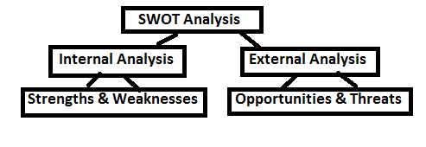

The opportunities and threats are present in the external environment of a firm and the internal environment of a firm comprises of strengths and weaknesses.

**Internal Environment Analysis (Strengths/Weakness Analysis)**

It is necessary to analyse one’s own strengths and weaknesses periodically to sustain the degree of its competitive strength.

**Strengths:**

It is an inherent capacity which an organization uses to gain strategic advantage over its competitions. It is necessary that a business organization does not have to correct all its weaknesses, nor that it propagate its strengths. The success of the company depends on whether its business strengths not only match the key success requirements for operating in the target market but also excel when compared to those of its competitors. The best performing company is one, which can generate the greatest customer value and sustain it over a given period of time.

**Weaknesses:**

It is an inherent limitation which creates a strategic disadvantage. Weaknesses include those factors which tend to reduce the capabilities of the organization when compared to its competitors.

Generally companies earn a competitive edge over the competitor with the strength and fail due to weaknesses. Some of the important areas where the strengths and weaknesses of the companies are identified are marketing, human resources etc.

**Marketing:-**

|  |  |
| --- | --- |
| **Strengths** | **weaknesses** |
| 1.Strong brand image | 1.Poor brand image |
| 2.Strong distribution network | 2.Weak distribution network |
| 3.Perfect product mix | 3.Poor product mix |
| 4.Efficient marketing department | 4.Poor sales force |
| 5.High quality of product | 5.Low quality of product |

**Human Resources:-**

|  |  |
| --- | --- |
| **Strengths** | **weaknesses** |
| 1.Qualified and experienced human resources | 1.In experienced human resources |
| 2.Good industrial relations | 2.Poor industrial relations |
| 3.GoodHRM | 3.Poor HRM |
| 4.Highly dedicated and committed employees | 4.Employees with low morale and not committees |
| 5.Sufficient manpower | 5,Excess/Less manpower |

**External Environment Analysis (Opportunity and Threat Analysis)**

The external environment has a profound impact on the business operations irrespective of the nature and size of the business. The business has to monitor its key macro-environment forces and micro-economic parties.

**Opportunities:**

Opportunity is a favorable condition in the organizations environment which enables it to consolidate and strengthen its position. It is necessary that the company should identify what opportunities are available to it to focus upon. The latest technology, deregulated or free markets, liberalized rules and regulations are the examples of opportunities.

**Threats:**

Some developments in the external environment represent threats. A threat is a challenge posed by an unfavorable trend or a development that result in the loss of sales or profit. A few examples of threat could be outlined as change in government policy such as liberalization, privatization and globalization, changing technologies, changing value systems, environmental constraints, deteriorating law and order and so on.

Some of the important opportunities and threats to the business organizations are:

|  |  |
| --- | --- |
| **Opportunities** | **Threats** |
| 1.Enter new markets | 1.Entry of new competitors |
| 2.Add complementary products | 2.Rising sales of substitute products |
| 3.Large potential for exports | 3.Diminance of the small scale industries |
| 4.Large, faster growing market | 4.Small, slower market growth |
| 5.Import relaxation | 5.Import liberation |

Based on the degree of threat and its impact on business, the business can be the following four types

**1. Ideal Business:**

A business is said to be one when it has a large number of major opportunities and a minimum number of threats.

**2. Speculative Business:**

A business is said to be a speculative one when it has a large number of both opportunities and threats

**3. Mature Business:**

A business is said to be a mature one when it has a lower number of opportunities and threats.

**4. Troubled Business:**

A business is said to be a troubled one when it has a lower number of opportunities and a high number of threats.

**SWOT Analysis Significance**

SWOT Analysis provides four alternative strategies to deal with the factors in the external and the internal environment. They are:

**(i) The Threat – Weakness (TW) Strategy:-**

This attempts to minimize both weaknesses and threats. As a part of this strategy, the firm may have to add to the product base or the range of services by taking over the competitor’s business.

**(ii) The Opportunity – Weakness (OW) Strategy:-**

Here, the weaknesses are minimized while the opportunities are maximized. As a part of this strategy, the firm can overcome its weaknesses by developing the necessary competencies among the work force by investing moderately, in the latest technology and thus, offering products of the best quality to its customers.

**(iii) The Strength – Threat (ST) Strategy:-**

This strategy enables the firm to address the threats through its strengths. The focus is to maximize the strengths and minimize the weaknesses. As a part of this strategy, the firm can seek long-term and low-interest loans to minimize the cost of its operations.

**(iv) The Strength – Opportunity (SO) Strategy:-**

This is the most preferred strategy. Here, the firm can take advantage of the available opportunities through its present strengths. As a part of this strategy the firm can consider expanding into new markets with the existing products and services.

**Limitations of SWOT Analysis**

SWOT Analysis is not free from its limitations. It may cause organizations to view circumstances as very simple because of which the organizations might overlook certain key strategic contact which may occur. Moreover, categorizing aspects as strengths, weaknesses, opportunities and threats might be very subjective as there is great degree of uncertainty in market. SWOT Analysis does stress upon the significance of these 4 aspects. But it does not tell how an organization can identify these aspects for itself.

There are certain limitations of SWOT Analysis which are not in control of management. These include:

1. Insufficient research and development facilities.

2. Faculty products due to poor quality control

3. Poor industrial relations

4. Lack of skilled and efficient labour etc.

**Describe the steps in Environmental Scanning – Explain**

Every organization has an internal and external [environment](https://www.toppr.com/guides/geography/environment/environment/). In order for the organization to be successful, it is important that it scans its environment regularly to assess its [developments](https://www.toppr.com/guides/economics/development/development-in-india/) and understand factors that can contribute to its success. Environmental scanning is a [process](https://www.toppr.com/guides/fundamentals-of-economics-and-management-cma/organising/process-of-organizing/) used by organizations to monitor their external and internal environments.

The purpose of the scan is the identification of opportunities and threats affecting the business for making strategic business decisions. As a part of the environmental scanning process, the [organization](https://www.toppr.com/guides/business-management-entrepreneurship/organizing/structure-of-organization/) collects information regarding its environment and analyzes it to forecast the impact of changes in the environment. This eventually helps the management team to make informed [decisions](https://www.toppr.com/guides/fundamentals-of-economics-and-management/decision-making/types-of-decisions/).

**Importance of Environmental Scanning**

**1. SWOT Analysis:**Environmental Scanning is both a complex and important process. The study of both internal and external environment provides valuable information about an organization related to its strengths, weakness, opportunities, and threats (SWOT).

[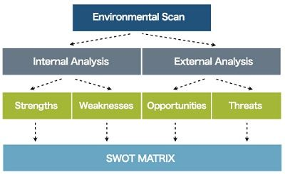](https://studiousguy.com/wp-content/uploads/2019/10/swot-analysis.jpg)

* **Strengths:** Environmental scanning provides useful insights into an organization’s strengths by analyzing its internal environment that offers a competitive advantage to its business. This information can be used to strengthen these strengths to maximize their profits.
* **Weakness:** Internal environmental scanning also helps in determining the weaknesses of the organization. The timely corrective measures are required for these weaknesses to achieve growth and stability in an organization.
* **Opportunity:** Environmental scanning also analyzes external environment factors that facilitate identifying different opportunities for businesses in the external market and to grasp these opportunities, different strategies can be made well in advance.
* **Threats:** Identification of different threats whether its competitors or any other factor of the external market is equally important for business growth and its smooth operation. Environmental scanning helps in analyzing such threats so that organizations can develop strategies to either remove or minimize the effects of these threats.

**2. Optimum utilization of resources:**An organization can grow and achieve its objectives by utilizing its available resources i.e. human, capital or non-human properly and up to a maximum extent. In this, environmental scanning plays a vital role by conducting a detailed analysis of the utilization of these resources. With this analysis, organizations can control the wastage of resources by utilizing them effectively and efficiently.

**3. Growth and survival:**By analyzing both internal and external environment important factors i.e. SWOT analysis, Environmental scanning prepares the organization to tap any opportunities and threats of the future and simultaneously to improve its strengths by removing weaknesses.

**4. Long-term planning:**Businesses are required to have both long-term and short-term plans. The long-term objectives of planning can be determined by thorough analysis and environmental scanning. It facilitates business owners to develop the required business strategy.

**5. Assists in the decision-making process:**With the help of environmental scanning, an organization can decide the best alternatives among different available alternatives to take an effective decision for the organization’s success and growth.

**Process of Environmental Scanning**

[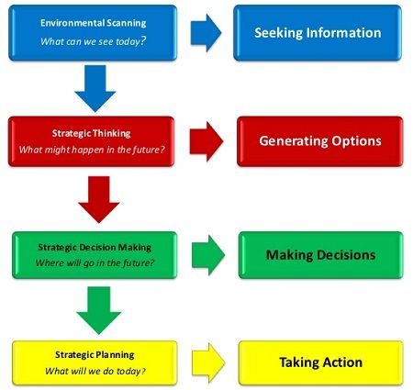](https://studiousguy.com/wp-content/uploads/2019/10/environmental-scanning-process.jpg)

Through the Environmental Scanning process, an organization can understand its business environment in which it operates. In each stage of the environmental scanning process, the organization can respond and manage changes that may happen in both its internal and external environment. The scanning process is also considered as a beneficial tool for strategic management as it helps in formulating and implementing the organization’s objectives by providing a detailed assessment of the internal and external environment.

**Environmental Scanning process consists of following steps that are inter-related to each other:**

* The environmental scanning process starts with the **identification of requirements and concerns** that have created the reason for which organization decides for environmental scanning. Different factors that are considered before initiating the process include the scanning purpose, participants of the process, the resource allocation and duration of environmental scanning.
* The next step of the scanning process includes **collecting the information**. The organization’s requirements are defined in the necessary information that is beneficial in the scanning process.
* Further, all collected information of the organization is **analyzed**. While analyzing, different trends or concerns are highlighted that may influence the organization.
* The fourth step includes **communicating results** that are derived from the information analysis.
* After obtaining all relevant information from the above steps, the next step is related to **making decisions** using all information. Different appropriate measures are taken by the organization to strengthen its position in the current business environment.

**Outline the steps in Strategy Formulation and Implementation**

**Introduction - Meaning**:

Strategy formulation and Implementation is the common problem of the strategic management process. Strategy refers to the course of action desired to achieve the objectives of the enterprise. Formulation, together with its implementation constitutes an integral part of the managerial activity. Managers use strategies for different purposes such as to overcome competition to increase sales, to increase production, to motivate the employees, to provide their best and so on.

Implementation of a strategy is a crucial task as the formulation. There may be a lot of resistance during the implementation process. It is the members of his group in the formulation of strategy to facilitate the implementation process.

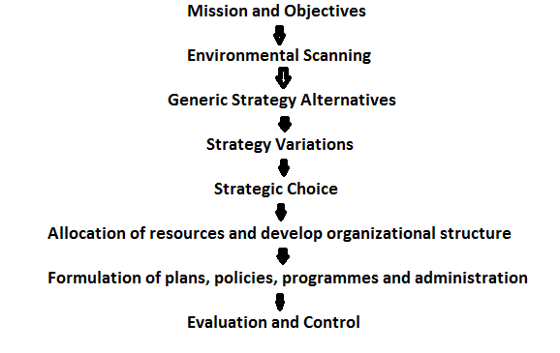

**1. Mission and Objectives:**

Mission is also called ‘overall objective’ or ‘overall goal’. For long – term survival, the corporate have to gain acceptability in the society and this is achieved through mission. A mission statement defines why the organization exists.

Once the mission is clear, goals are fixed for individual department, the next stage is to break down the goal into objectives for every level in the organization. At every level in the organization determination of objective is very essential. Objectives maybe general or specific. As the managerial process gets more and more complex, objectives continue to guide the managers in their day-to-day performance. This is the first step in the process of strategy formulation and implementation.

**2. Environmental Scanning:**

After identification of mission and objectives the next step is environmental scanning. Environmental scanning aims at identifying the new opportunities in which the form can perform profitably. It involves an analysis and diagnosis of the external and internal business environment. In external environment the opportunities and threats are analyzed. In internal business environment strengths and weaknesses are analyzed.

**3. Generic Strategy Alternatives:**

After the nature of business of the firm is defined, the next task is to focus on the type of strategic alternative. There are 4 strategic alternatives for any business. They are: to expand, to wind up, to stabilize, to combine its operations pertaining to its products, markets.

**(a) Expansion Strategy:-**

This strategy can be adopted in the case of highly competitive and unsteady industries, particularly, if they are in the introduction stage of product or service life cycle.

**(b)Retrenchment Strategy:-**

This is the clear choice when the firm is not doing well in terms of sales or revenue and finds greater returns of the product or service is in the finishing stage of the product life cycle.

(c)Stability:- this is a better choice when the firm is doing well, the environment is relatively less volatile and the product or service has reached the maturity stage of the life cycle.

**(d)Combination Strategy:-**

It is not a new strategy as it combines the other strategies. Large diversified organization commonly uses a number of these strategies in combination.

**4. Strategy Variations:**

There can be a number of variations of the generic strategy alternatives. Ex: if the strategy is to expand, then the alternatives are internal expansion or external expansion. Internal expansion can be achieved through any of the following approaches:

Find out new markets

Add new markets

Add new products and so on.

Similarly, external expansion can be achieved through mergers or acquisitions.

If the strategy is to attain stability, then the alternatives could be internal stability or external stability. In some cases both may be required. Each of these variations has different strategic alternatives considering the major goals of the organization.

**5. Selection of the best alternative:**

The best alternative is the one that can improve the performance. The selection of the right alternative depends upon the

Particular configuration of objectives

Environmental threat and opportunity profile

Strategic advantage profile

The generic strategy itself.

**6. Strategic Choice:**

Here the exact strategy is chosen. Strategic choice involves the decision to select from among the alternatives, the best strategy which effectively contributes to the business objectives.

**7. Allocation of resources and development of organizational structure:**

The process of strategy formulation calls for an integrated set of choices and activities. These include allocating resources, organizing, assigning appropriate authority to the key managers, setting policies and developing procedures. It is necessary to establish an operative system to reinforce, control and evaluate a strategy.

**8. Formulation of policies, plans, programmes and administration:**

The resources allocated are said to be well utilized only when they are well monitored. For this purpose, it is essential

To develop policies and plans

To assign leaders the tasks and decisions to support the chosen strategy

To provide a conductive environment in the organization

Formulate the policies, plans and programmes to give enough force to the strategy.

**9. Evaluation and control of strategy:**

Evaluation is the last phase of the strategic management process. At this stage that the success of the programmes can be assessed. There should be a built in mechanism to examine the deviations and initiate corrections as and when required. This assures that the chosen strategies will be implemented properly.

Periodic evaluation and feedback enables the top management to assess the progress from stage to stage. Corrective measures have to be taken as the situation demand. A strategy can well be implemented if the staff is efficient, has a shared vision and a developed culture and value system. It is the management responsibility to ensure a conductive environment that faster the effective implementation of strategies.

**Explain the steps in Strategy Formulation**

**Definition**: Strategy Formulation is an **analytical process of selection of the best suitable course of action to meet the organizational objectives and vision**. It is one of the steps of the [strategic management](https://businessjargons.com/strategic-management.html) process. The strategic plan allows an organization to examine its resources, provides a financial plan and establishes the most appropriate action plan for increasing profits.

It is examined through **SWOT** analysis. SWOT is an acronym for strength, weakness, opportunity and threat. The strategic plan should be informed to all the employees so that they know the company’s objectives, mission and vision. It provides direction and focus to the employees.

## Steps of Strategy Formulation

The steps of strategy formulation include the following:

[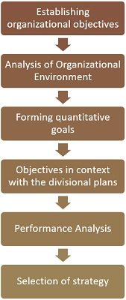](https://businessjargons.com/wp-content/uploads/2018/07/process-of-strategy-formulation1.jpg)

1. **Establishing Organizational Objectives**: This involves establishing long-term goals of an [organization](https://businessjargons.com/organization.html). Strategic decisions can be taken once the organizational objectives are determined.
2. **Analysis of Organizational Environment**: This involves SWOT analysis, meaning identifying the company’s strengths and weaknesses and keeping vigilance over competitors’ actions to understand opportunities and threats.

Strengths and weaknesses are internal factors which the company has control over. Opportunities and threats, on the other hand, are external factors over which the company has no control. A successful organization builds on its strengths, overcomes its weakness, identifies new opportunities and protects against external threats.

1. **Forming quantitative goals**: Defining targets so as to meet the company’s short-term and long-term objectives. Example, 30% increase in revenue this year of a company.
2. **Objectives in context with divisional plans**: This involves setting up targets for every department so that they work in coherence with the organization as a whole.
3. **Performance Analysis**: This is done to estimate the degree of variation between the actual and the standard performance of an organization.
4. **Selection of Strategy**: This is the final step of strategy formulation. It involves evaluation of the alternatives and selection of the best [strategy](https://businessjargons.com/business-strategy.html) amongst them to be the strategy of the organization.

Strategy formulation process is an integral part of strategic management, as it helps in framing effective strategies for the organization, to survive and grow in the dynamic [business environment](https://businessjargons.com/business-environment.html).

### Levels of strategy formulation

There are three levels of strategy formulation used in an organization:  
[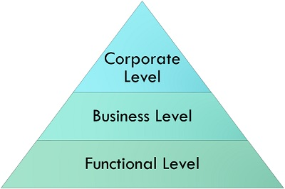](https://businessjargons.com/wp-content/uploads/2018/07/Levels-of-strategy-formulation.jpg)

* **Corporate level strategy**: This level outlines what you want to achieve: growth, stability, acquisition or retrenchment. It focuses on what [business](https://businessjargons.com/business.html) you are going to enter the market.
* **Business level strategy**: This level answers the question of how you are going to compete. It plays a role in those organizations which have smaller units of business and each is considered as the [strategic business unit (SBU)](https://businessjargons.com/strategic-business-unit.html).
* **Functional level strategy**: This level concentrates on how an organization is going to grow. It defines daily actions including allocation of resources to deliver corporate and business level strategies.

Hence, all organisations have competitors, and it is the strategy that enables one business to become more successful and established than the other.